**Lab4 AI Report**

Made by:

**Ahmad Said Nouh (7086)**

**Ahmed Alaa Tawfik (6842)**

**Hussein Mourad Kassem (6729)**

**Hossam Eldin Ahmed Eissa (6747)**

Contents

Algorithms: 3

**Decision Tree:** 3

Confusion Matrix: 3

**AdaBoost:** 3

Parameter tuning: 3

Confusion Matrix: 4

**K-NN:** 4

Parameter tuning: 4

Confusion Matrix: 5

**Random Forests:** 5

Parameter tuning: 5

Confusion Matrix: 6

**Naive Bayes:** 7

Confusion Matrix: 7

Comment: 7

Bonus 8

Parameter tuning: 8

Confusion Matrix: 8

|  |  |  |
| --- | --- | --- |
|  | Predicted (h) | Predicted (g) |
| Actual (h) | TN | FP |
| Actual (g) | FN | TP |

# Preprocessed:

## **(1e-3):**

### Confusion Matrix:

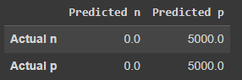

Test Accuracy: 0.500

Percision : 0.0

Sensitivity (Recall) : nan

Specifity : 0.5

F1 Score = nan

### Graph:

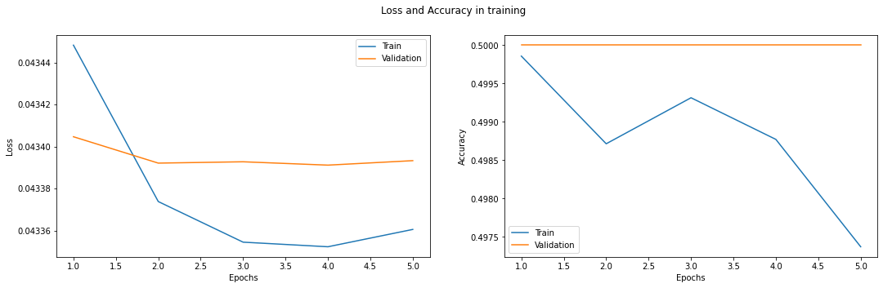 

## **(5e-4):**

### Confusion Matrix:

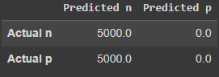

Test Accuracy: 0.500

Percision : 1.0

Sensitivity (Recall) : 0.5

Specifity : nan

F1 Score = 0.6666666666666666

### Graphs:

